Lab 7

- Sample of plain and cipher text for AES and DES
AES Plain text

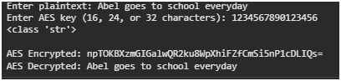

AES cipher text

DES plain text and cipher text
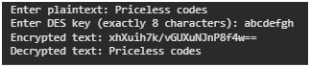

Real image

Cipher image
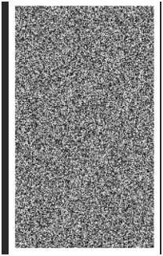

The encryption method appears good because:
- The encrypted image looks like random noise.
- There are no visible patterns from the original image.
- Pixel structure and shapes are completely obscured.
- It shows high confusion and diffusion (key properties of strong encryption).

